Missing Content/Images

1. Images - Banner section in **Support Landing Page**: Desktop/Mobile

**Creative:** <https://newell.invisionapp.com/share/SWDL1VN56#/screens/254418372>

**Creative:** <https://resourceammirati.invisionapp.com/share/PKBYL3GX3#/screens/250259828>

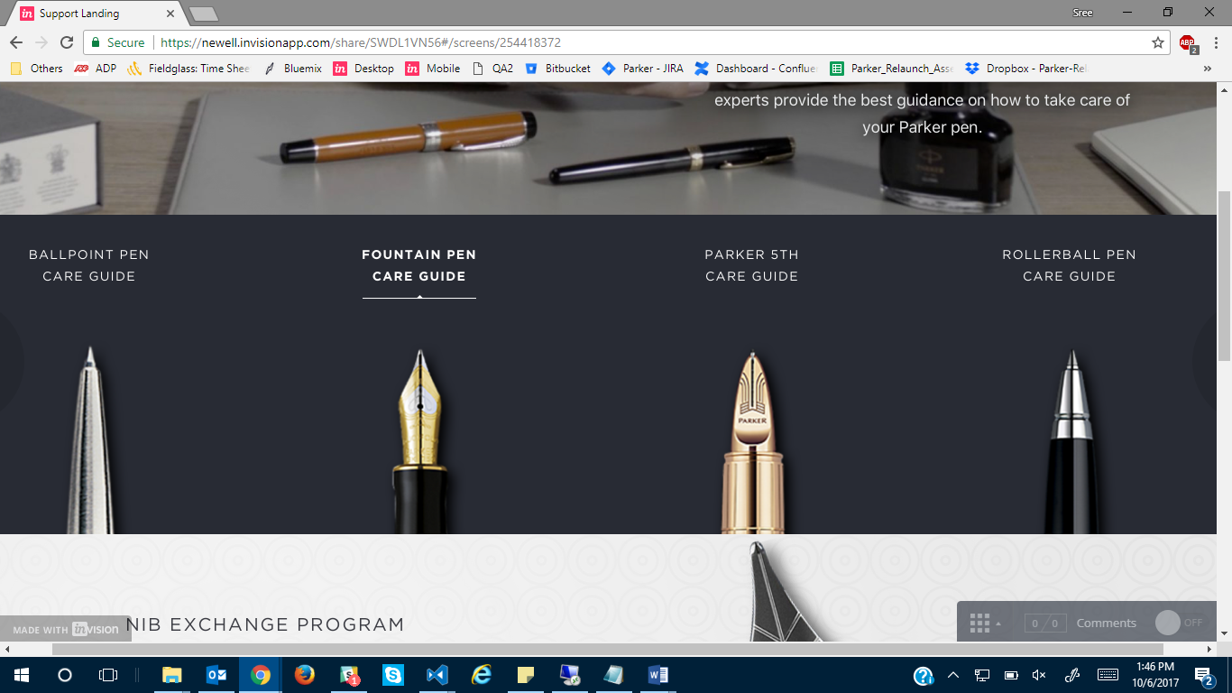

**Care Guides:**

1. Images for Care Guides Details Ballpoint
2. Images for Care Guides Details Fountain Pen
3. Images for Care Guides Details Parker 5th
4. Images for Care Guides Details Rollerball

Banner for Desktop/Mobile is provided to the above pages. As per the discussion with Alex, we are not going to have banner/videos for Care Guides.

Images for all these pages are needed in place of videos.

**Creative:** <https://newell.invisionapp.com/share/SWDL1VN56#/screens/254417656>

1. Images for **Nib Exchange Program**

**Creative:** <https://newell.invisionapp.com/share/SWDL1VN56#/screens/255099059>

1. Content/Images for **Return and Exchange**